nano@illinois
Research Experiences for Teachers (RET)

Natto Cells as Nanoactuators for Origami Based Locomotion
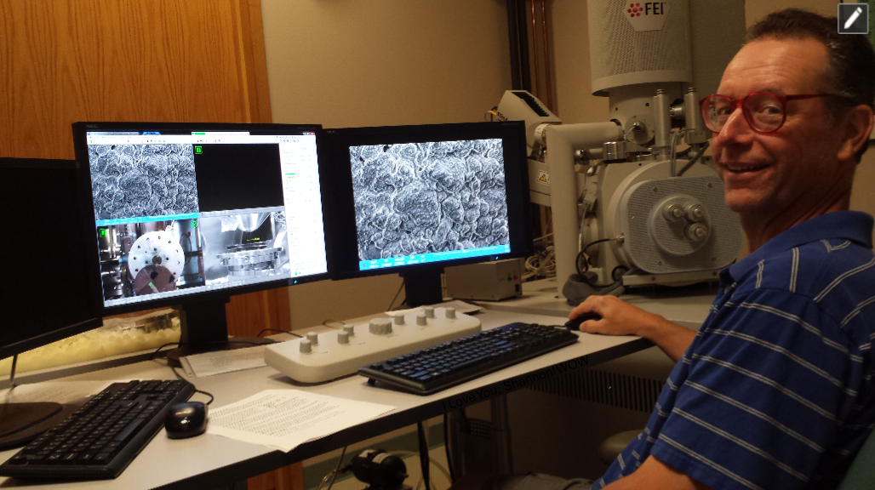
Bryan P. Schroeder
Danville High School
Danville, IL

2017-2018
Module Description:
Students will become familiar with efforts to use biological food-grade spores as the driving force for mechanical locomotion.

Learning Objectives:
After completing this activity, students will be able to observe the effect of forces supplied by the swelling and contraction of the peptidoglycan layer (cortex) surrounding a vegetative spore of Bacillis subtilis.
After completing this lesson, students will be able to understand the summative power of sub-microscopic particles as a motive force, and recognize the advantages of locomotion driven by biological responses.

Target Grade Level(s):
This module could be used in an upper level Physical or Life Science course where the students are proficient at following meticulous details in a lab setting.

Prerequisite Knowledge/Skills:
For this module, students should have lab skills sufficiently developed to follow very specific directions on a minute scale with great accuracy.
For this module, students should be familiar with the structure of both vegetative bacteria and the spore stage, and the biological mechanics involved in the absorption of water by the spores.
For this module, students need to have an understanding of the responsiveness of living organisms to the environment, and how the stimulation and harnessing of said responsiveness would have unique benefits.

Background:
The idea behind this module is to replace traditional, artificial sources of locomotion and power such as engines, gears, wires, etc., with living cells; the use of bacterial cells and/or spores as living nano-actuators. An early application of this idea uses origami.
Origami based locomotion requires the application of a force sufficient to initiate controlled snapping in the macro structure as the inherent buckling instability of the folds is overcome.
The replacement of human developed actuators (e.g. wires and electronics) with natural actuators such natto cells has several advantages, including safety (natto is food grade), mechanical flexibility of components, and an inexpensive power source (relative humidity gradient).
Natto, the biological source of force, is a traditional Japanese fermented soybean dish made using the bacterium Bacillus subtilis. The vegetative and endospore states of B. subtilis swell in response to increased humidity. In non-survivable conditions, bacteria package their DNA into a “survival capsule” called an endospore. When favorable conditions return, the cortex (peptidoglycan) of the endospore, or spore, first absorbs water and swells, a highly reversible and repeatable process.
This physical swelling, when harnessed via biohybrid film, provides sufficient force to overcome the buckling instability in origami folds.
A biofilm is made by applying a suspension of Bacillus subtilis in deionized water and Elmer’s glue to a substrate of polyimide tape and allowed to dry. The spores spread out and form a monolayer which will expand and contract based on humidity levels. Since the polyimide tape itself will not respond to changes in moisture levels, the overall tape will curve, generating a force sufficient enough to drive motion or electrical generation.
This module will involve using Bacillus subtilis spores from a commercial natto source and create a bilayer biofilm which would respond to changes in ambient humidity. The response will manifest as a predictable and reversible mechanical deformation in the biofilm. This deformation will then be evidence of proof of concept that such a biofilm can potentially be used as a biological source of power for origami locomotion.

Materials
Mitoku Traditional Natto Spores as the source of B. subtilis
Poly-L-lysine solution 0.1% (w/v) in H₂O from Sigma-Aldrich
Mist Humidifier (suggested: Crane Filter-Free Cool Mist Humidifier, Penguin)
1 Mil Polyimide tape (e.g. Kapton) for the basis of the Biofilm
PET sheets, 76.2 μm thick
Elmer's White Glue (diluted 10:1 with water)
Small binder clips
Clear plastic tote, approximately 10-20 L in size
Approximately 6 feet of ½" diameter plastic tubing

Preparation of B. subtilis from Natto Spores – Prepare at least one day ahead of time.
- Add 0.5 g of commercial natto powder to 5 mL water.
- Agitate well to facilitate rehydration of spores.
- Refrigerate up to 1 week.

Figure 1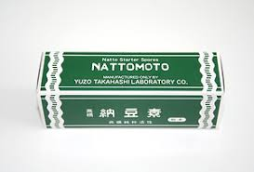

Preparation of the Biofilm – For each "hinge":
- Cut two rectangles from PET film, 25mm x 15mm (the supporting tabs)
- Using the polyimide tape (passive layer), secure the rectangles 2.5 mm apart, short ends adjacent.
- Apply Poly-L lysine solution to cover the polyimide tape (passive substrate). Set in a protected area for 24 hours, allowing the liquid to evaporate undisturbed (preferably at 40% RH). This provides better adhesion between the B. subtilis spores and polyimide film.
Figure 2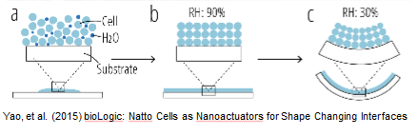

Assemblage of Bending Strip
- Combine 1 mL prepared B. subtilis with 1.0 mL diluted Elmer's glue (this will form the active layer)
- Add the above solution to the polyimide tape, concentrating at the gap between the PET tabs. Allow to dry for 24 hours.
Figure 3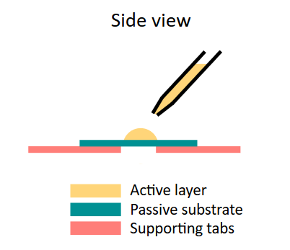

Rehydration of dehydrated spores on bending strip, and subsequent movement of passive substrate by an increase in localized humidity.

- Prepare mist humidifier for operation. To increase visibility for observation, insert plastic tubing into source of mist. Secure other end in plastic tote, covering with a large sheet of PET.
- Secure one end of PET tab of Bending Strip vertically in a binder clip (to reduce the effect of gravity on the strip).
- Place Bending Strip and binder clip in plastic tote and cover.
- Increased humidity in tote will elicit a response within five minutes.
Figure 4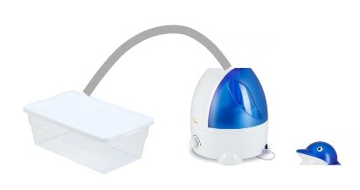

Extensions
- Replace Bending Strips with Kresling towers. Copy the pattern shown in Figure 6, and fold into the shape of the "Unit" in Figure 5. Secure three Units end to end to form a Kresling tower. Cover each vertical joint with a thin piece of latex or nitrile, coating with the Natto/glue solution. Place in humidity chamber and observe for up to one hour.

Figure 5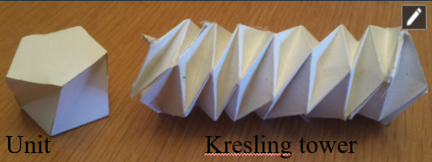

Figure 6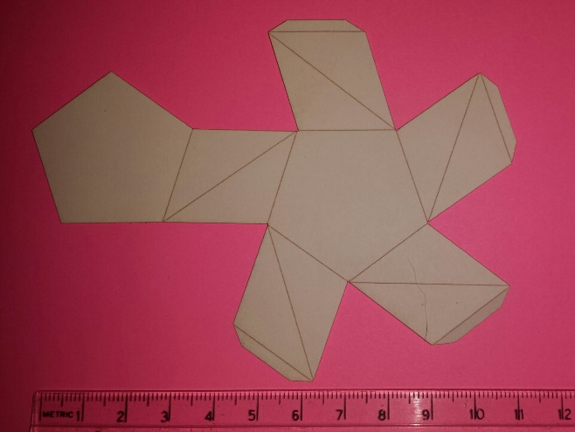

- Replace Polyimide tape with SPEX 3511 Kapton Window Film, 0.3 mil Thickness. Secure to PET with glue. Observe speed of movement.
- Replace Natto cells with Saccharomyces cerevisiae.

Post-Lab Questions for Natto Cells as Nanoactuators

- What is the purpose of the cortex (peptidoglycan) of the bacteria?

The cortex forms a protective layer around the DNA of the bacteria, forming a type of life capsule in times of severe stress when the bacteria would otherwise die.

- How are the mechanics of cortex exploited as a means of a nanoactuator?

With sufficient environmental moisture, the cortex abosrbs water and expands, preparing the bacteria for reanimation. Since this process is repeatedly reversible, the expansion and contraction can act as a type of biological piston engine.

- Would the SPEX respond much more quickly or more slowly than the original polyimide tape? Explain your answer.

The SPEX should respond much more quickly than the original polyimide tape due the greatly reduced weight of the SPEX, owing to the thinner material (1.0 mil vs. 0.3 mils)

- Would other bacteria be a good choice as a replacement for B. subtilis? Explain your answer.

To be a good choice, any other bacteria would need to have a cortex that responds quickly, is reversible, and is not toxic.

- What other improvements would need to be made to this experiment in order for the results to be commercially viable?

A much quicker response to the introduction of humidity; much greater generation of force that is presently seen. Accept any other logical answers.

References
Chen et al. (2014). Bacillus spores as building blocks for stimuli-responsive materials and nanogenerators. Nature Nanotechnology. 2014 Feb;9(2):137-41. doi: 10.1038/nnano.2013.290. Epub 2014 Jan 26.
Alexander Pagano, Brandon Leung, Brian Chien, Tongxi Yan, A. Wissa, S. Tawfick. (2016). University of Illinois Urbana-Champaign, Urbana, IL. Multi-Stable Origami Structure for Crawling Locomotion. ASME 2016 Conference on Smart Materials, Adaptive Structures and Intelligent Systems.
Yao, et al. (2015). bioLogic: Natto Cells as Nanoactuators for Shape Changing Interfaces. Proceedings of the 33rd Annual ACM Conference on Human Factors in Computing Systems.

Financial support was provided by the National Science Foundation under grant #NSF EEC 14-07194 RET, as part of the nano@illinois Research Experiences for Teachers (RET) project, managed and coordinated through the Center for Nanoscale Science and Technology and the Micro and Nanotechnology Lab at the University of Illinois at Urbana-Champaign. www.nano.illinois.edu
I would like to thank my faculty mentor, Dr. Sam Tawfick, my research mentor, Alex Pagano, and lab assistant Neal Boyer for their invaluable guidance and assistance during this project, in addition to project managers Dr. Irfan Ahmad and Carrie Kouadio, and technical staff at the Micro and Nanotechnology Lab, and Center for Nanoscale Science and Technology support.

